W7 QUIZ-2
CODING EXERCICE

Build the bellow screen in Flutter, following the specifications:

TO SUBMIT: Complete the start code

Note: you can use VS Code to code and test

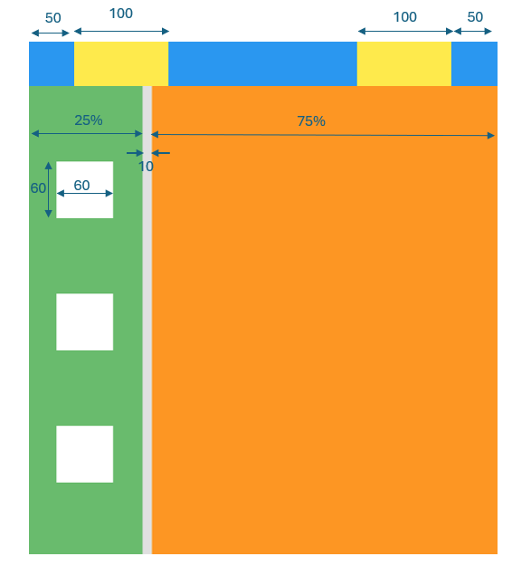

Responsive Behavior
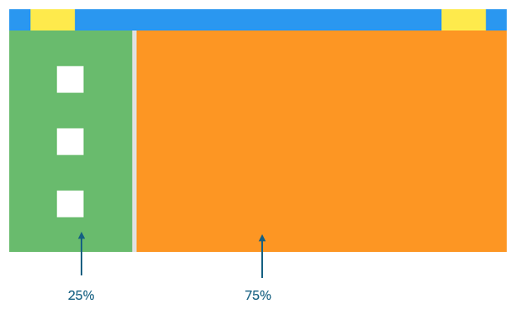

Start Code

import 'package:flutter/material.dart';

void main() {
runApp(
MaterialApp(
debugShowCheckedModeBanner: false,
home: Scaffold(
backgroundColor: Colors.grey[300],
body: Column(
// YOUR CODE
),
),
),
);
}

